1 OVERVIEW

1.1 Business Goals

State the business goals of the system. Examples of the goals are: reduce turnaround time, streamlining of data exchanges between customers and suppliers.

1.2 Business Process Overview

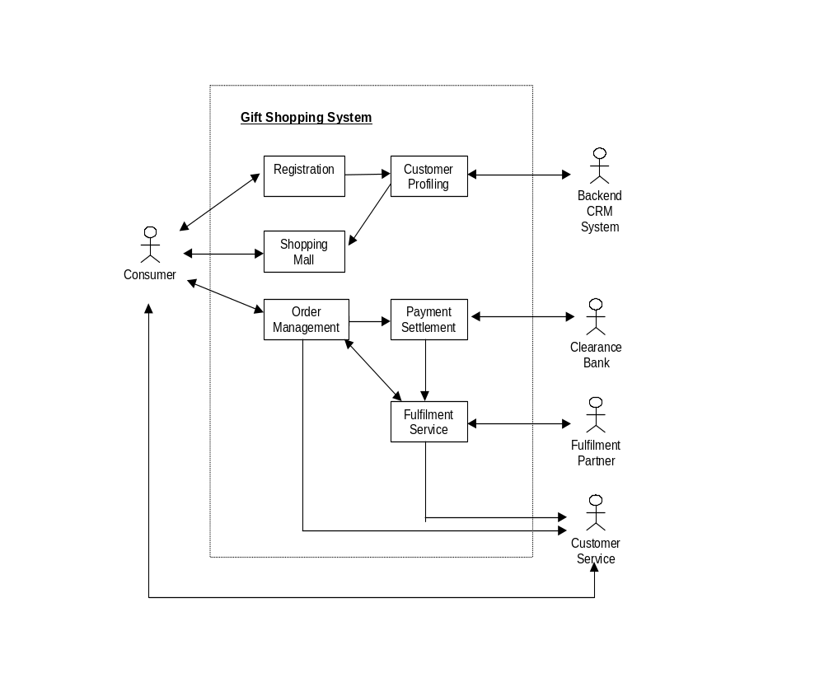 Provide an overview of the processes the system is supporting. Focus on the interactions between the different roles (eg. consumer, clearance bank, fulfilment partner) and how these roles move through the business processes. It is highly recommended to supplement with a diagram to depict the overview of the processes. A sample of the diagram is as follow:

1.3 Objectives of System

State the objectives of the system in terms of critical business processes to be enabled by IT. This would facilitate subsequent prioritisation. Examples of processes are : Order Management and Payment Settlement.

2 BUSINESS PROCESS

For each business process identified in the overview, document the process map and business function.

2.1 Process map

An example of a process map is as shown below :

Order Management Process
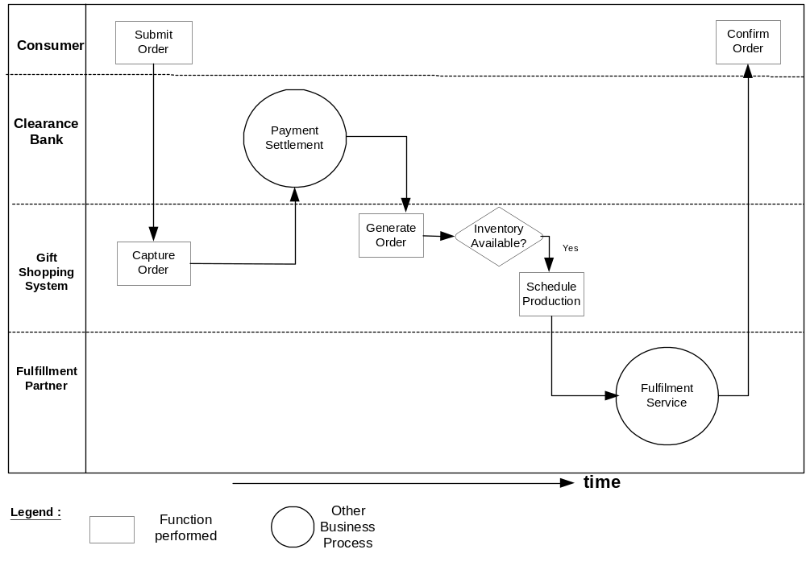

2.2 Business Functions

List the business functions (sub-process) to be computerised.

3 BUSINESS FUNCTIONS

3.1 Functional Overview

Organise the business functions to be computerised. Depict the overview of business functions using Functional Hierarchy as shown below :

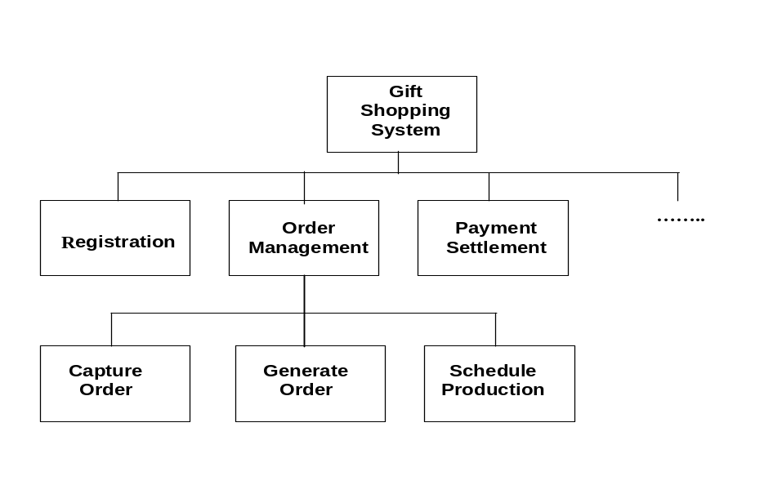

3.2 Functional Requirements

For each business function, document the following :

Description of the function
Provide brief descriptions of the functionalities of the process.

Roles
List the Roles participating in the business function. A Role can be an individual (eg. applicant) or an external system.

Input
List input used and reference or attach the layout

Output
List output that are produced and reference or attach the layout

Flow of Events
Depict the following flow of events :
- Normal / typical flow of events
- alternative flow of events (eg. to handle exceptions)

The following shows possible ways of capturing the flow of events :

a) Event Table

Sequence No. | Role’s Action | System Response

- 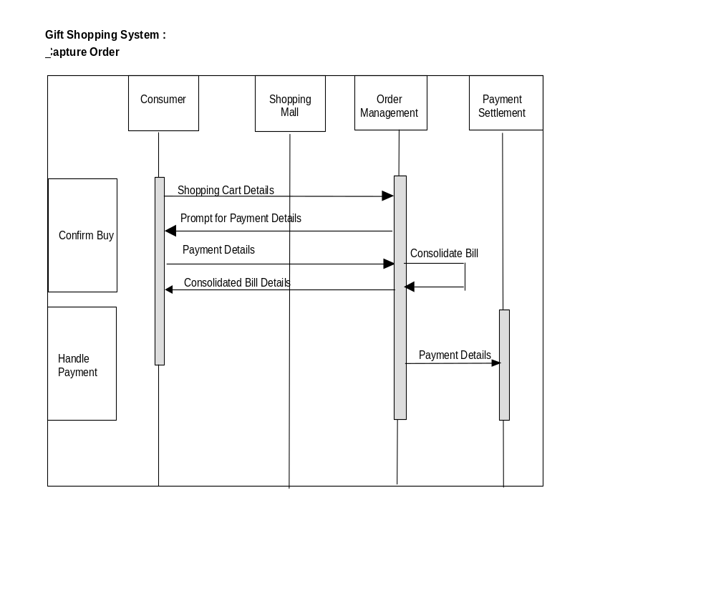Sequence Diagram

Business Processing Rules
Document the key validation and update rules. For example :
- Calculation formulae
- Algorithm and check digit
- Access control requirements (eg. for purchases > $10,000 only the “premium” consumer can confirm buy, logging of all buy transactions for accountability and audit purposes)
- Type of batch printing, where applicable (eg. indicate whether the batch printing is activated by operator or user via on-line function)

Transaction Volume
List the average and peak volume for a specified period of time (eg., average 500 buy transactions to be processed per month).

4 OTHER REQUIREMENTS

Document the details of other requirements pertaining to :
- Technical requirements
- Generic requirements that support across functions

The typical requirements are documented as follows :

- SYSTEM PERFORMANCE

State the required system performance, if applicable. Specify the following:

- System response and turnaround time (include definition of the response time and turnaround time)

- System availability (e.g. operational hours for normal working days, weekends and public holidays)

- SECURITY REQUIREMENTS

- Specify user groups that can have access to the application and the various functions and data within the application; List any other security requirements (e.g. user authentication and mechanism, encryption and key management control, audit control)

- Specify security classification of the application and data

- EXTERNAL INTERFACES

For each external interface, describe the data transfer requirements and the characteristics of communication media/systems used for the transfer. For example:

- Data Format, mode and frequency of the exchange of the data transfer
- Security considerations for transfer
- Media of interfacing (e.g. tape, network, diskette, etc.)
- Timing and/or dependencies of the transmitted and received data
- Future needs of interface systems (if any) which may have impact on the proposed system

- ARCHIVAL REQUIREMENTS

State the following :

- Retention period for each type of information

- Actions to be taken after the retention period (eg. to transfer to off-line media, or to delete them)

- If transfer to off-line media, state the period to be stored and the types of storage media (e.g., tapes, diskettes, reports etc.)

- Reasons for the proposed archival policy (if necessary)

- CONTINGENCY REQUIREMENTS

For critical business functions, specify :

- Tolerable downtime

- Types of records, frequency (daily, weekly etc.) and retention period of the backup

- Fallback mechanism to continue operations during downtime ( eg. switch to another alternative computerised system, rely on localised processing, resort to manual procedures, etc.)

- CONVERSION REQUIREMENTS

State existing manual or computerised files (eg. text or graphics) to be converted. If required, document the following information :

- Conversion approach (eg. one time or in stages, impact on the existing operation routine)
- Types of records and data to be converted
- Conversion rules (eg. old code no. to new code no.)
- Cut-off date of how far back the data should be converted
- Types and no. of conversion reports required assumptions (eg. exclusion of some fields or records for conversion, storing the unconverted records on the specific media)

- STATUTORY REQUIREMENTS

Highlight statutory/regulatory requirements and constraints such as laws or critical policies or procedures.

5 SYSTEM/OPERATING ENVIRONMENT

Define the system environment and network infrastructure. Illustrate with diagram (if needed) to describe user location with respect to the host system/server and input/output equipment and document the following :

a) Communications Overview
Specify the method of communication that will support the system (e.g. network layout and features)

b) Hardware Requirements/Configuration
Specify the hardware requirements/configuration, which include number of workstations, peripherals and customer location for installation of hardware.

c) System Software
List the system software required (eg. operating system, utilities) and indicate version/release number and other pertinent details.

6 ASSUMPTIONS AND LIMITATIONS

State and explain any assumptions or limitations that will have impact on the scope, design and implementation of the proposed system.

7 USER INTERFACE DESIGN CONCEPT

Document the user interface design concept/standard for the system. For Web Applications, document the design theme for the web page and describe the design concept for the following :
- Background
- Screen layout (provide sample, if necessary)
- User interactions
- Text font / style
- Icons
- Buttons
- Frames
- Header / Footer / Terms and Conditions

8 SCENARIO FLOW / USER INTERFACE DEMO

Describe the typical scenario of an end-to-end user experience by putting yourself in the user’s shoes. For each role, focus on a targeted set of users who are ready to perform a transaction. Think through the likely/commonly occurred scenarios these users will need to perform. Depict the flow in terms of inter-linked screens/web pages that allow the user to complete a transaction from end-to-end as shown below:
